**Title:** Salinity Variation, Plant-Herbivore Interactions, and Community Composition on Rocky Shores

**Authors:** Theraesa A. Coyle, Rebecca L. Kordas And Christopher D. G. Harley

**Abstract:**

-Complete after finalizing manuscript

**Introduction:**

Sea water salinity is an important abiotic influence on marine communities in estuarine systems. Salinity varies both spatially and temporally, in response to distance from freshwater sources, periods of peak freshwater inflow, and oceanographic currents (Zacharias and Roff 2001; Ysebaert and Herman 2002, ref for currents?). These salinity changes are a stressor for marine organisms, affecting both survival and physiological function. For example, hyposaline conditions have been shown to cause decreased heart rate, reduced haemolymph osmolality and mortality in limpets (De Pirro et al. 1999; Chelazzi et al. 2001; Firth and Williams 2009), as well as reduced pigment production, decreased growth rate and decreased photosynthetic rate in algal species (Chakraborty et al. 2010; Karsten and Kirst 1989; Kumar et al. 2010; others).

Differences in tolerance and physiological response to environmental stressors can lead to indirect effects on community structure and composition in marine intertidal environments. For example, (Example of temperature stressor having indirect effects on intertidal communities by disproportionately affecting one species – get from BK). Natural salinity gradients have been shown to influence intertidal species diversity (Zacharias and Roff 2001; Hampel et al. 2009; Rubal et al. 2012), succession (Ritter et al. 2005) and community structure (Schoch et al. 2006 *check this ref*), though few studies have addressed the mechanisms by which salinity can indirectly alter intertidal communities (see Witman and Grange 1998 and Nielsen and Gosselin 2011 for examples). Identifying these indirect paths that drive patterns of abundance and distribution is critical for understanding how environmental stress shapes ecological communities.

The Strait of Georgia, British Columbia, presents a unique and ideal environment for studying the effects of salinity on coastal communities. The 220km strait is located between Vancouver Island and mainland BC, and is partially isolated from the Pacific Ocean by restricted flow through narrow channels around the northern and southern tips of the island (Figure 1). Seasonal variation in freshwater influx via the Fraser River, regularly reaching a mean of more than 7000m³/s in summer months (Masson 2006; Halverson and Pawlowicz 2008 or check Environment Canada), causes a corresponding variation in sea surface salinity near the Fraser plume, with an annual drop from approximately 25 psu to less than 15 psu during peak discharge (Halverson and Pawlowicz 2011; Held and Harley 2009;). This effect, however, declines with increasing distance from the estuary, with waters southeast of the Southern Gulf Islands maintaining salinities of 23 psu to 30 psu year round (Tully and Dodimead 1957; Halverson and Pawlowicz 2011).

We hypothesized that this variation in sea surface salinity would lead to different patterns in intertidal community composition between mainland West Vancouver and the Southern Gulf Islands. We further expected that observed patterns would be driven both directly, by differences in salinity tolerance between different intertidal species, and indirectly, as a result of biological interactions with affected species. Because limpet species have been shown to be highly susceptible to low salinity stress compared to algae and other invertebrates, and because limpet density has been shown to impact algal abundance (Branch 1981; Cubit 1984), we predicted that limpet abundance would both differ between the two regions and impact abundance of other intertidal taxa. We performed biological sampling surveys in these two salinity regions, as well as laboratory tolerance experiments and a field exclusion experiment, in order to address the following questions:

1. How does intertidal community composition differ between the high salinity region of the Southern Gulf Islands and the low salinity region of West Vancouver?
2. Are limpets more sensitive to low salinity stress than their prey species, and does observed sea surface salinity in West Vancouver exceed limpet tolerance?
3. Does limpet sensitivity to salinity drive observed differences in community composition between the high and low salinity region?

**Methods:**

*Study Sites*

-Description of location, salinity, sea surface temperature, geomorphology, slope, aspect and tidal range at each site.

-Refer to Figure 1 (Map).

-Possibly edit map to show salinity patterns

-Consider changing order to Transect Surveys, Exclusion experiments, Lab studies (see Discussion for explanation)

*Transect Surveys*

-Description of timing, height, length, sampling area and number of transects.

*Salinity Tolerance Experiments*

i) Salinity and tidal emersion tolerance of *Lottia* spp.

-Description of tidal experiment procedures (either reference thesis or supplemental)

ii) Salinity tolerance and local adaptation of *L. pelta*

-Description of limpet tolerance experiment

iii) Salinity Tolerance of *Ulva* sp.

-Description of ulva tolerance experiment.

*Field Exclusion Experiments*

-Description of field experiments

*Statistical Analyses*

-Description of statistics used (once decided upon)

**Results**

*Spatial and Temporal Variation in Salinity*

-Qualitative description of seasonal salinity patterns

-Refer to Figure 2 (Graph of Salinity overlayed with Fraser River Outflow)

*Transect Surveys*

-Ordination of samples shows differences in communities between the high and low salinity regions.

-Differences are driven by Chthamalus and Limpets in the high salinity region and Fucus and Mytilus in the low salinity region.

-Add table with relevant statistics: Simper?

-No differences between months.

-Refer to Figure 3 (Transect Data NMDS Plot)

-Consider changing order to Transect Surveys, Exclusion experiments, Lab studies (see Discussion for explanation)

*Tolerance Experiments*

i) Limpets

-Proportion of live limpets stabilized by the 28th day in all cases.

-Survival of *L. pelta* from both regions was significantly greater above 11 psu than below (ANOVA, P<0.0001).

-Survival of limpets from separate regions differed significantly only in the 11 psu salinity treatment, in which limpets from the low salinity region had greater survival (ANOVA, P=0.023).

-No significant effect of tidal treatments on salinity tolerance (ditch this?)

-Refer to Figure 4 (Plots of limpet survival over time in each salinity treatment)

ii) Ulva

-Unimodal relationship between Ulva survival (measured by change in mass) and Salinity with maximum growth at 15psu and losses at 0psu and 30psu

-R2=0.482, P<0.0001

-Similar relationship with ETRmax, with maximum at 20 psu and minimum at 0 psu

-R2=0.712 (No P value due to lack of sampling points)

-Refer to Figure 5 (Regression plots for Ulva)

*Field Exclusion Experiments*

-Differences in settled communities evaluated in July, after sufficient time to allow community recovery from initial disturbance.

- Zero-inflated negative binomial mixed effects models show significant effects of treatment and treatment*region on chthamalus and green algae

-Add table with statistics from these models

-Discuss effects on Fucus and Mytilus? (Not related to treatments, only to region)

-Refer to Figure 6 (Bar plots of Chthamalus and Greens abundance)

**Discussion:**

Our study indicates that the observed differences in intertidal community composition between the Southern Gulf Islands and West Vancouver are partially driven by both the direct and indirect effects of salinity. The dramatic reduction in salinity during the summer months caused by high inflows of freshwater from the Fraser River creates a stressful hyposaline environment along the West Vancouver shoreline. Despite signs of local adaptation to seasonal lows, the sustained exposure to waters of less than 10 psu is sufficient to cause mass mortality of limpets. This direct effect on limpet abundance then has indirect effects on the larger intertidal community. Released from the stress of predation, and capable of growing in waters as low as 4 psu, green algae proliferate. Perhaps as a result of displacement or smothering by the green algae, the brown barnacle *Chthamalus dalli* is reduced in abundance. Facilitative interactions have been proposed to exist between grazers and barnacles, in which grazing reduces competition for space between barnacles and algae (Benedetti-Cecchi 2000; Lohse and Raimondi 2007). Similar patterns of positive influences on *Chthamalus spp.* by grazer presence have been found by Dungan (1986) and Harley (2006).

This scenario is supported by evidence from our field and laboratory studies. Sea water sampling at sites in the Southern Gulf Islands and West Vancouver shows that while both regions are affected by Fraser plume, West Vancouver sites reach and sustain much lower salinities (Figure 2). Observational biological sampling shows that there are consistent differences in community composition between the high and low salinity regions, with greater abundance of limpets and *C. dalli* in the high salinity sites and *F. gardneri* and *M. trossulus* in the low salinity sites (Figure 3). Field limpet exclusion experiments illustrate that, in the absence of limpets, high salinity communities resemble those of low salinity region with respect to green alga and *C. dalli* abundance (Figure 6 – Consider changing figure order). This suggests that limpet absence drives these patterns. Finally, our laboratory salinity tolerance experiments confirm that summer salinity levels at West Vancouver are low enough to kill limpets, but not green algae (Figure 4 and 5 – Consider changing order). Though we did not test it directly in this study, many barnacle species have been shown to have a high tolerance to salinity stress, as well as a high capacity for adaptation, even within a single generation (Dineen and Hines 1994; Qiu and Qian 1999).

This study takes advantage of a natural salinity gradient that exists within the Strait of Georgia, but there are several other environmental variables that vary, both between the two regions and the individual sites, which likely influence these intertidal communities. Other abiotic conditions, including rainfall, temperature, acidity, shoreline geomorphology and nutrient availability, can vary both spatially and temporally, and can impact species both directly and indirectly. For example, the prevalence of *M. trossulus* and *F. gardneri* in low salinity sites may be due to interactions with other predators and competitors, or differences in recruitment or attachment success. Detailed studies on the mechanisms that drive these patterns would further our understanding of the ecology of this system.

The results of our study illustrate how physiological stress can propagate through ecological systems, creating both positive and negative indirect effects on species abundance. Abiotic conditions that vary in both space and time can lead to dynamic patterns in species distribution and abundance along these spatiotemporal gradients. The changes in oceanic salinity that are expected with climate change are patchy and highly dependent on the individual climatic trends in a given area. Rising atmospheric CO2 concentrations are expected to heterogeneously alter oceanic salinity via changes in the global hydrological cycle (Held and Soden 2006). In coastal areas, climatic models have shown that changing patterns of precipitation and snowmelt will alter runoff from major rivers, causing associated changes in the salinity of estuarine systems (Melack et al. 1997; Huang and Mehta 2010). The effects of salinity changes in conjunction with increased temperature and acidification are poorly understood at best. While intertidal populations have demonstrated a capacity for local adaptation, the expected changes to the global hydrological cycle are likely to alter the structure and composition of coastal communities. Understanding the effects of salinity on community level dynamics may therefore prove essential to predicting the direction of such change in coastal ecosystems.

**References:**

**Figure Captions**

**Fig. 1** Map of the study region. Low salinity sites are located in West Vancouver and high salinity sites are located in the Gulf Islands.

**Fig. 2** Measured surface salinity (psu) from sites in the Gulf Islands (shaded) and in West Vancouver (unshaded), British Columbia. Dashed line indicates Fraser River discharge rate (10³m³/s) measured at Hope, British Columbia (Environment Canada, 2012). Surface salinity for Eagle Cove, April 7, 2011, was influenced by heavy rainfall.

**Fig. 3** NMDS Plot of Transect Data

**Fig. 4** Mean proportion of *L. pelta* from the Gulf Islands (●) and West Vancouver (△) alive at each day for four of six salinity treatments (n=3). Patterns observed at 17 and 20 psu were similar to that of 14 psu. Error bars indicate standard error.

**Fig. 5** (a) Change in mass (g) and (b) ETRmax of *Ulva* sp. vs. salinity. Lines indicate least-squares regression.

**Fig. 6** Mean (a) abundance of *Chthamalus dalli* and (b) percent cover of green algae in each treatment at high and low salinity sites.

**Figure 1**

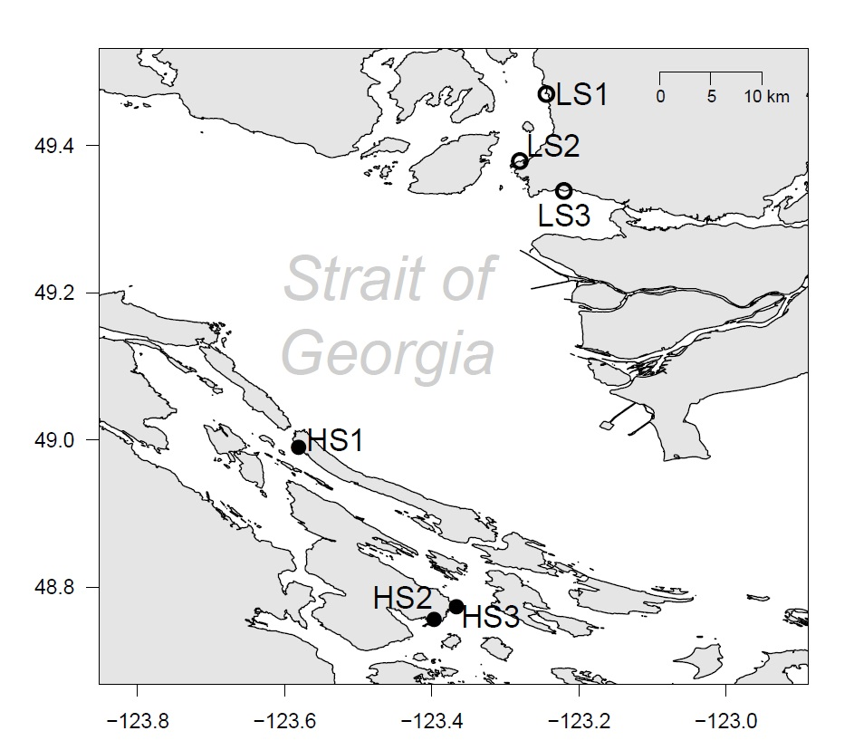

-Try to get salinity colour map

**Figure 2**

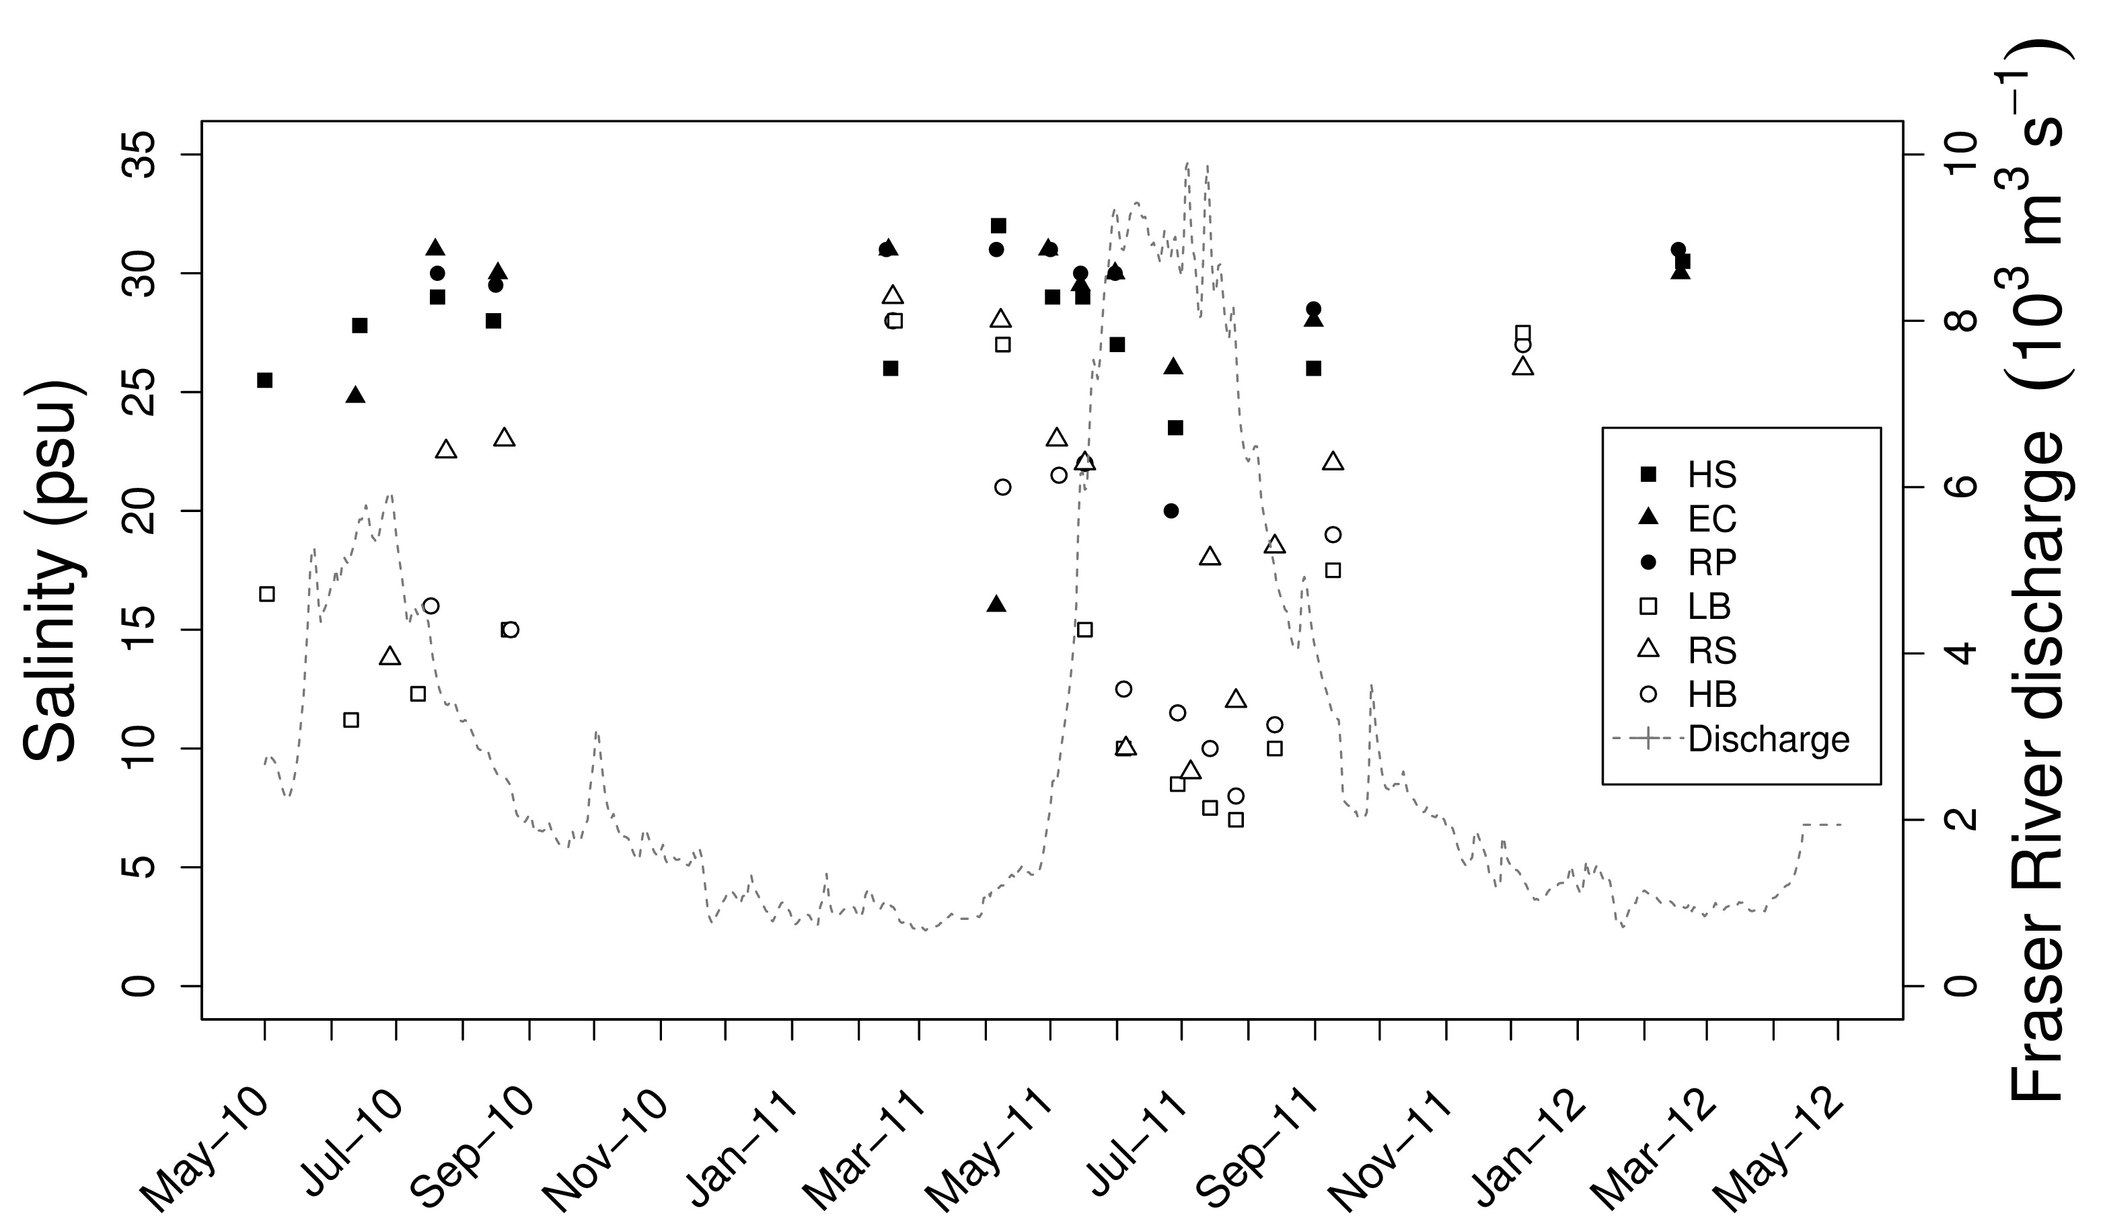

**-**Try fitting stiff spline to salinity data to create a curve, pooling sites within regions

**Figure 3**

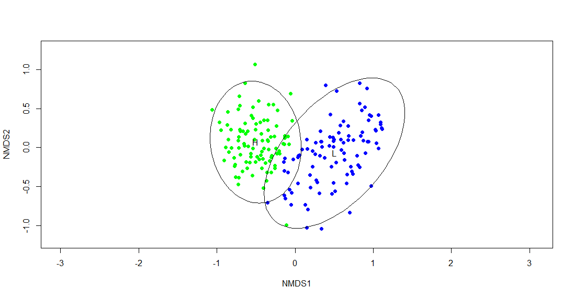

**Figure 4**



**Figure 5**

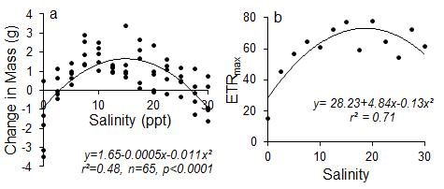

**-**Change to PSU

**Figure 6**

